**Deep Neural Network-Driven Identification and Quantitative Validation of Key Driver Genes in Head and Neck Squamous Cell Carcinoma**

**Suggested Study Title/Focus**

**“Uncovering Non-Canonical Gene Programs in HNSCC Using Latent Space Feature Attribution”**

or

**“Deep Latent Representations Identify Dispersed but Predictive Gene Signatures in HNSCC”**

**What Is the Scientific Purpose or Outcome of the Study?**

Let me help frame it.

**🧪 Scientific Purpose:**

To uncover **latent biological programs** driving tumor heterogeneity in **HNSCC** using **unsupervised deep learning (VAE)**, and to identify gene signatures with **functional, prognostic, and therapeutic relevance**.

**📜 Potential Study Titles:**

**🔹 General / Conceptual**

* “Uncovering Latent Biological Programs in Head and Neck Cancer Using Variational Autoencoders”
* “Learning Hidden Gene Expression Programs in HNSCC via Deep Generative Modeling”

**🔹 Functional/Targeted**

* “A Deep Latent Space Approach Reveals Immune and Hypoxia Programs in HNSCC”
* “VAE-Based Latent Feature Discovery Identifies Prognostic and Therapeutic Gene Signatures in Head and Neck Cancer”

**🔹 Translational Angle**

* “Decoding Tumor Heterogeneity in HNSCC via Deep Latent Modeling: Toward Biomarkers and Therapeutic Targets”

**INTRODUCTION**

**• STRING network is PPI-focused, but VAEs learn nonlinear expression patterns — they capture statistical importance, not just physical interactions.**

**• These genes may:**

* **Be involved in independent regulatory programs.**
* **Be part of non-interacting but co-expressed modules.**
* **Represent novel or under-characterized biology in HNSCC.**

**Method**

1. Input Data
2. PCA
3. VAE Training using Two-fold
4. Runing Integrated Gradients for Each Fold

now let me share what i understand. so i have 50 latent from two VAE fold ( so should i call two VAE model or 100 model?) now we will back analyze like we will take ine latent and map it with PCA * gene labels and rank them with geen atrributes like some scores and ( they are dcalled importance score?) and we take these scores and mean on both fold to keep one score for one llatent. now we get some gene lists for every latent and we can alos rank them based on the importance score ruiught?  
  
Exactly—you’ve got it. Let me restate cleanly:

1. **Two VAE models, not 100 models.**
   * You trained **Fold 0** and **Fold 1** separately, each a VAE with 50 latent dimensions.
   * Together they produce **2 × 50 = 100 raw latent vectors**, but they come from **two models**, not 100 different models.
2. **Back‐mapping each latent to genes via PCA loadings + IG**
   * For each latent jj in each fold, you compute **Integrated Gradients** in PCA‐space → a vector of length 500 (one score per PC).
   * You then multiply by the PCA **loading matrix** (genes × PCs) to get a **gene‐attribution vector** for that latent (genes × 1).
3. **Importance scores**
   * Those gene‐attribution values are your **importance scores**—they tell you how strongly each gene drives that latent dimension.
   * You do this **separately for Fold 0 and Fold 1**.
4. **Averaging across folds**
   * For each latent jj, you now have two gene‐importance vectors (one per fold).
   * You take the **elementwise mean** to get a single, more robust **gene‐importance vector** for latent jj.
5. **Ranked gene lists**
   * For each of your 50 latents, you end up with one final gene‐importance vector.
   * You can **rank** that list by absolute importance (or signed if you care about direction) to pick the top-NN genes for downstream interpretation.

So in Step 3 you:

* Treat **two models** (fold 0 & 1) × **50 latents**
* Produce **100 gene‐importance vectors**
* **Average** them to get **50 consensus gene‐importance signatures**
* **Rank** each signature’s genes by importance for biological analysis

That gives you a transparent bridge from each abstract latent axis back to the actual genes driving it.

We translate each of our 50 learned abstract dimensions into concrete gene scores—by combining IG on the VAE with the PCA gene‐loadings—then average across folds. The result is 50 gene‐importance signatures, one per latent dimension, ready for pathway analysis or biomarker discovery.

**From latent → PCA inputs → genes**

1. **Integrated Gradients (IG)** gives you, for each latent node jjj, a score for **each PCA component** kkk:

\mathrm{IG}_{k,j} = \text{“how much PCA‐component }k\text{ pushes on latent }j”}

1. You know how each PCA component is itself a mixture of real **genes** (your PCA loadings matrix). If PCA component kkk loads heavily on gene ggg, then a large IGk,j\mathrm{IG}_{k,j}IGk,j​ means “gene ggg also strongly drives latent jjj.”
2. **Mapping** is just a matrix multiply:

(genes × PCs)  ×  (PCs × latents)  =  (genes × latents) \textbf{(genes × PCs)} \;\times\; \textbf{(PCs × latents)} \;=\; \textbf{(genes × latents)}(genes × PCs)×(PCs × latents)=(genes × latents)

→ You end up with one “gene × latent” attribution table per fold.

1. Ensemble Feature

In this step we will cluster latent features from each VAE model, which will help to keep the similar types of features together.

initially ihave genee xpression data as some stat methods cant extract the biology out from it we introduced deep NN and first step we used PCA to reduce the dimention. then we trin our VAE model among different folds and options (add some technical language in this like like we tried 100, 50 latent but 50 seems best because of what reconstruction loss low or somhting?) then we select 50 latent to go further in downstream analysis. now we have 50 laatent spac eto check that which space goes with HNScc and whichlatent holds be best biology i mean genes or group of genes . so what is the 3rd step and what we are showing?

**RESULT**

Step 1

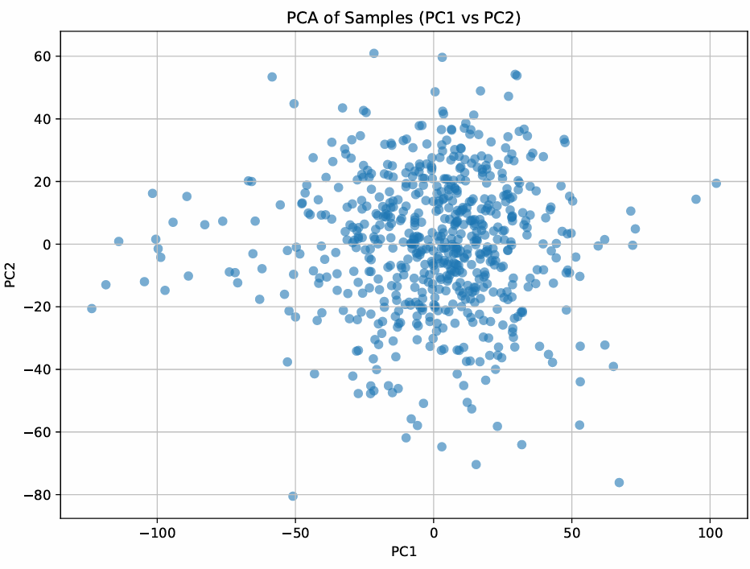

**Step 1: PCA Dimensionality Reduction**

**1. Scree Plot (Explained Variance)**

“The scree plot of the top 50 principal components shows that each PC explains only a small fraction of the total variance—roughly 0.15–0.20% per component. There is no single dramatic ‘elbow,’ indicating that variance is distributed diffusely across many dimensions. By retaining the first 50 PCs (which together capture about 10% of the total variance), we reduce noise and dimensionality while preserving a representative sample of the overall structure in the data.”

**2. PC1 vs PC2 Scatter (Sample Distribution)**

“Plotting samples on the first two PCs reveals a fairly continuous cloud without tight clusters. This suggests that head-neck cancer samples do not naturally separate along just PC1 and PC2, but the spread indicates meaningful variation. Downstream models (VAEs) will therefore benefit from these 50 PCs to uncover more subtle, nonlinear structure that isn’t visible in the first two axes alone.”

**Step_2_VAE**

In this reconstruction‐error plot, we trained VAEs with latent dimensions of 5, 10, 25, 50, 75, and 100.

* Both **training** (blue) and **validation** (orange) error **steadily decrease** as we increase the latent size, from about **8.6** at 5 dims down to **6.8** (train) and **7.3** (val) at 100 dims.
* The **validation curve closely tracks** the training curve at every point, indicating **no sign of overfitting** even at higher dimensions.
* Notice that **most of the gain happens by 50 dimensions**—beyond that the error reduction **levels off**, so doubling to 100 dims only improves reconstruction marginally.

**Conclusion:** A latent space of **~50** dimensions captures almost all the signal (minimizes reconstruction error) without adding unnecessary complexity—making it our sweet spot for downstream analysis.

**Interpreting these 20 genes**

* We chose the **20 genes whose absolute attributions sum highest** across all 50 latent dimensions—i.e., those that **most strongly drive** your VAE’s representation of HNSCC.
* These genes are **prime candidates** for being biologically important in HNSCC: they repeatedly surfaced as key drivers of latent axes capturing tumor variation.
* **Next steps** to confirm their relevance might include:
  + **Pathway enrichment** (GO/KEGG) on these 20 to see shared functions.
  + **Literature mining** to check prior HNSCC associations.
  + **Experimental validation** (e.g. qPCR) in independent samples.

In short, yes—these 20 are your **top‐ranked** genes by model‐derived importance, and therefore excellent starting points for biological follow‐up in head-and-neck cancer.

**Result Interpretation of the Dendrogram Heatmap**

**The heatmap you generated visualizes the top 20 most important genes across 50 latent features, where:**

1. **The heatmap shows the gene‐latent relationships, with gene names on the left and latent features across the top.**
2. **The colors represent the mean Integrated Gradient (IG) attribution, with darker colors indicating lower attribution and lighter colors showing higher attribution.**
   * **Genes/latents with higher intensity colors suggest they contribute more strongly to the latent space, meaning these genes have higher importance for that latent dimension.**
3. **Row dendrogram (left):**
   * **The hierarchical clustering of the genes shows how genes group together based on similar IG attribution patterns across the 50 latent features.**
   * **Genes that cluster together in the dendrogram are those that exhibit similar behavior in how they influence the latent space.**
4. **Column dendrogram (top):**
   * **The hierarchical clustering of the latents shows how the 50 latent features group together based on their gene attribution profiles.**
   * **Latents that cluster together indicate they are capturing similar biological signals or processes in the data.**

**Key Takeaways**

* **The top 20 genes are the most influential in shaping the 50 latent features. These genes were ranked by total IG attribution across the latents, meaning they were found to drive the most important latent dimensions.**
* **The hierarchical clustering allows you to see how genes and latents group together based on their co‐variation.**
* **The dendrogram helps identify which latents capture similar biology (gene sets) and which genes influence multiple latent dimensions.**

**Context for HNSCC**

**Given the context of your study (Head and Neck Squamous Cell Carcinoma - HNSCC), this heatmap can be used to:**

1. **Identify key biological processes in HNSCC: For example, genes involved in immune response, cell proliferation, or metabolism may cluster together in certain latents, offering insights into underlying tumor biology.**
2. **Pinpoint biomarkers: Genes that show high attribution in multiple latents might be valuable for diagnosis, prognosis, or treatment targets.**
3. **Explore heterogeneous patterns: The clustering of genes across latents could help you detect subtypes of HNSCC, especially when considering how gene groups are distributed across samples.**

**Next Steps:**

* **Pathway enrichment analysis (e.g., Gene Ontology, KEGG) for the top genes to further interpret which biological processes or pathways they are involved in.**
* **Experimental validation of top genes to see if they are functionally relevant in HNSCC.**

**This heatmap is a good first step in interpreting the latent space in terms of known biology!**

**Discussion**

**• STRING network is PPI-focused, but VAEs learn nonlinear expression patterns — they capture statistical importance, not just physical interactions.**

**• These genes may:**

* **Be involved in independent regulatory programs.**
* **Be part of non-interacting but co-expressed modules.**
* **Represent novel or under-characterized biology in HNSCC.**

**Conclusion**

**Your observation that genes don’t form a strong STRING network is itself a key result. It suggests:**

* **HNSCC gene regulation (as captured by VAE) is heterogeneous, possibly more modular or diffuse.**
* **Your model is identifying non-obvious, possibly novel gene patterns.**
* **This can set up a future study — e.g., what governs these disconnected genes? Are they controlled by epigenetics, non-coding RNAs, or microenvironmental signals?**